Android audio system: from Audiotrack to Audioflinger

- Overview of the Android audio framework
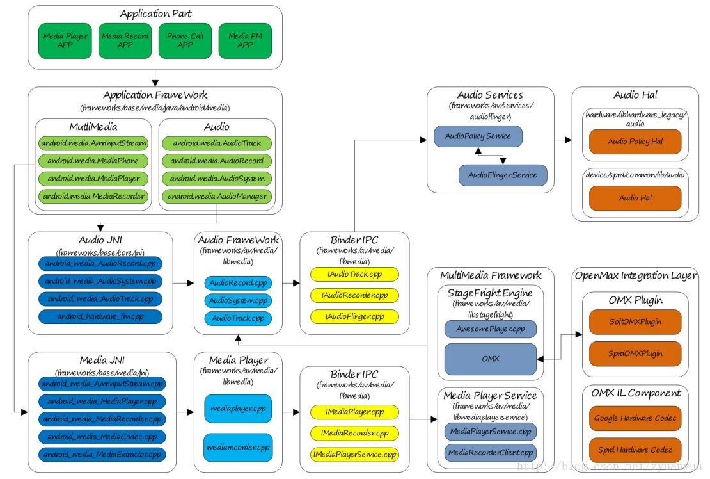

Audio is a very important part of the entire Android platform, responsible for the acquisition and output of audio data, audio stream control, audio equipment management, volume adjustment, etc., mainly include the following parts:

- Audio ApplicationFramework: Audio application Frame

- Audiotrack: is responsible for the output of playback data, is the Android application framework API class

- Audiorecord: Responsible for the collection of recorded data, is the Android application framework API class

  - Audiosystem: Responsible for the integrated management of audio transactions, the Android application framework API class
- Audio Nativeframework: Audio Local frame

  - Audiotrack: is responsible for the output of playback data, is the Android local framework API class

- Audiorecord: Responsible for the collection of recorded data, belonging to the Android local framework API class

  - Audiosystem: Responsible for the integrated management of audio transactions, is the Android local framework API class
- AudioServices: Audio Service

  - Audiopolicyservice: The creator of audio strategy, responsible for the strategic choice of audio device switching, volume adjustment

strategy, etc.

  - Audioflinger: The executor of the audio policy, responsible for the management of the input and output stream devices and the processing and transmission of audio stream data

- Audio HAL: Audio hardware abstraction layer, responsible for interaction with audio hardware devices, called directly by Audioflinger

Related to Audio is Multimedia, multimedia responsible for the codec of audio and video, multimedia will decode the data through the Audiotrack output, and Audiorecord collected recording data to multimedia code.

2. Audiotrack API Overview

Playback sounds can be made using MediaPlayer and Audiotrack, both of which provide Java APIs for application developers. The difference between the two is that MediaPlayer can play sound sources in a variety of formats, such as MP3, FLAC, WMA, OGG, WAV, and so on, while Audiotrack can only play the decoded PCM data stream From the above Android audio system architecture diagram:.. MediaPlayer in the Native layer will create the corresponding audio

decoder and a audiotrack, the decoded data to audiotrack output Therefore, MediaPlayer's application scene is more extensive, in general, it is more convenient to use it; only some scenarios that are very demanding for sound latency require the use of audiotrack.

2.1. Audiotrack Java API

Audiotrack Java API Two data transfer modes:

Transfer
Mode

Mode_static

Mode_stream

Description

The application process pays the playback data to audiotrack at once, which is suitable for scenes with small amount of data and high latency requirements.

With processes that require continuous invocation of write () writing data to FIFO, there is a risk of blocking when writing data (Waiting for Audioflinger: data before consumption: P laybackthread), which basically applies to all audio scenes

Audiotrack Java API Audio stream type:

Stream Type Description

Stream_voice_call Telephony voice

Stream_system System sound

Stream_ring Ringtone sound, such as caller ringtones, alarm bells, etc.

Stream_music Music sound

Stream_alarm Warning tone

Stream_notification Notification tone

Stream_dtmf DTMF Tone (dial key tone)

- Why should Android define so many stream types This is related to Android's audio management strategy, such as:

  - Volume management of the audio stream, adjusting the volume of one type of audio stream without affecting other types of audio streams

  - Select the appropriate output device based on the stream type; for example, during a wired headset, the music Sound (Stream_music) will only be output to the wired headset, while the ringtone (stream_ring) will be output to both the Wired headset and the

These belong to the content of Audiopolicyservice, this article does not expand the analysis. The application developer should select the appropriate flow type based

on the scenario so that the system selects the appropriate output device for the stream.

A test example of a audiotrack Java API (mode_stream mode):

- Test case 1: setStereoVolume () with max volume returns SUCCESS @LargeTest

public void testSetStereoVolumeMax () throws Exception {
// constants for test

final String TEST_NAME = "testSetStereoVolumeMax"; final int TEST_SR = 22050;

final int TEST_CONF = AudioFormat.CHANNEL_OUT_STEREO; final int TEST_FORMAT = AudioFormat.ENCODING_PCM_16BIT; final int TEST_MODE = AudioTrack.MODE_STREAM;
final int TEST_STREAM_TYPE = AudioManager.STREAM_MUSIC;

- -------- initialization --------------

- LaterDetailed analysis getMinBufferSize

int minBuffSize = AudioTrack.getMinBufferSize (TEST_SR, TEST_CONF, TEST_FORMAT);
- Create AudioTrack Examples

AudioTrack track = new AudioTrack (TEST_STREAM_TYPE, TEST_SR,
TEST_CONF, TEST_FORMAT,
minBuffSize, TEST_MODE);

byte data [] = new byte [minBuffSize / 2];
- -------- test --------------

- transfer write () Written playback data track.write (data, 0, data.length); track.write (data, 0, data.length);

- transfer play () Start playing track.play ();
float maxVol = AudioTrack.getMaxVolume ();
assertTrue (TEST_NAME, track.setStereoVolume (maxVol, maxVol) ==

- -------- tear down --------------

- After the play finished,transfer release () freed AudioTrack Examples track.release ();
}

Detailed description of the getminbuffersize () interface, literally meaning to return the size of the minimum data buffer, it is the minimum guarantee that the sound can play normally, from the function parameters, the return value depends on the sample rate, sampling depth, channel number of these three properties. In Mode_stream mode, the application focuses on its return value and then determines how much data buffer is allocated. If the data buffer is allocated too small, then the playback sound will frequently encounter underrun, underrun means that the producer (Audiotrack) provides data at a rate that does not keep pace with the consumption of data by consumers (Audioflinger :: P laybackthread), The consequence of the reality is that the sound is intermittent carton, which seriously affects the auditory experience.

- AudioTrack.java / **

  - Returns the estimated minimum buffer size required for an AudioTrack
- Object to be created in the {@link #MODE_STREAM} mode.

- The size is an estimate because it does not consider either the route or the sink,

- Since neither is known yet. Note that this size does not

- Guarantee a smooth playback under load, and higher values should be chosen according to

- The expected frequency at which the buffer will be refilled with additional data to play.

- For example, if you intend to dynamically set the source sample rate of an AudioTrack

- To a higher value than the initial source sample rate, be sure to configure the buffer size

- Based on the highest planned sample rate.
- @Param sampleRateInHz the source sample rate expressed in Hz.
- {@Link AudioFormat # SAMPLE_RATE_UNSPECIFIED} is not permitted.

- @Param channelConfig describes the configuration of the audio channels.

- See {@link AudioFormat # CHANNEL_OUT_MONO} and
- {@Link AudioFormat # CHANNEL_OUT_STEREO}

- @Param audioFormat the format in which the audio data is represented.
- See {@link AudioFormat # ENCODING_PCM_16BIT} and
- {@Link AudioFormat # ENCODING_PCM_8BIT},
- And {@link AudioFormat # ENCODING_PCM_FLOAT}.

- @Return {@link #ERROR_BAD_VALUE} if an invalid parameter was passed,
- Or {@link #ERROR} if unable to query for output properties,
- Or the minimum buffer size expressed in bytes.
- /

static public int getMinBufferSize (int sampleRateInHz, int channelConfig, int audioFormat) {
int channelCount = 0;
switch (channelConfig) {

case AudioFormat.CHANNEL_OUT_MONO:
case AudioFormat.CHANNEL_CONFIGURATION_MONO:
channelCount = 1; // Mono

break;
case AudioFormat.CHANNEL_OUT_STEREO:
case AudioFormat.CHANNEL_CONFIGURATION_STEREO:

channelCount = 2; // Binaural
break;
default:

if (! isMultichannelConfigSupported (channelConfig)) { loge ( "getMinBufferSize (): Invalid channel

configuration.");
return ERROR_BAD_VALUE;
} Else {
channelCount = AudioFormat.channelCountFromOutChannelMask
(channelConfig);

}
}

if (! AudioFormat.isPublicEncoding (audioFormat)) {
loge ( "getMinBufferSize (): Invalid audio format.");
return ERROR_BAD_VALUE;
}

- sample rate, note these values are subject to change

- Note: AudioFormat.SAMPLE_RATE_UNSPECIFIED is not allowed if ((sampleRateInHz <AudioFormat.SAMPLE_RATE_HZ_MIN) ||

(SampleRateInHz> AudioFormat.SAMPLE_RATE_HZ_MAX)) {
loge ( "getMinBufferSize ():" + sampleRateInHz + "Hz is not a supported sample rate.");

return ERROR_BAD_VALUE; // CollectionSample rate support:4KHz ~

192KHz
}

- transfer JNI Method, the following analysisThe function

int size = native_get_min_buff_size (sampleRateInHz, channelCount, audioFormat);
if (size <= 0) {

loge ( "getMinBufferSize (): error querying hardware"); return ERROR;
}

else {
return size;
}

}

- android_media_AudioTrack.cpp

- ------------------------------------------------ -----------------------
-----

- returns the minimum required size for the successful creation of a streaming AudioTrack

- returns -1 if there was an error querying the hardware.

static jint android_media_AudioTrack_get_min_buff_size (JNIEnv * env, jobject thiz,

jint sampleRateInHertz, jint channelCount, jint audioFormat) {

size_t frameCount;

- transfer AudioTrack :: getMinFrameCount,Here not get to the bottom, to native Layer reanalysis

- This function is used to determineGiven at leastSet the number of frame To

PaulPermit normal playback sound, which is the minimum number of frames

const status_t status = AudioTrack :: getMinFrameCount (& frameCount,
AUDIO_STREAM_DEFAULT,
sampleRateInHertz);
if (status! = NO_ERROR) {

ALOGE ( "AudioTrack :: getMinFrameCount () for sample rate% d failed with status% d",
sampleRateInHertz, status);

return -1;
}

const audio_format_t format = audioFormatToNative (audioFormat); if (audio_has_proportional_frames (format)) {

const size_t bytesPerSample = audio_bytes_per_sample (format); return frameCount * channelCount * bytesPerSample; // PCM Minimum

dataBuffer Size

} Else {
return frameCount;
}
}

VisibleLeastBuffer size = lowestThe number of frames * Number of channels *

CollectionSample depth (sampling depth in bytes), Here you should be aware of it, in the

video, if the number of frames is too low, then the screen will have a sense of Carrington, for audio, the truth is the same. How the minimum number of frames is obtained, we go to the native layer to explain again.

For more detailed API interface instructions on MediaPlayer, Audiotrack, please refer to Android Developer:

- MediaPlayer:https://developer.android.com/reference/android/media/Media Player.html

- Audiotrack:https://developer.android.com/reference/android/media/AudioTr ack.html

2.2. Audiotrack Native API

Audiotrack Native API Four data transfer modes:

Transfer Mode Description

Take the initiative to request data from the application process through the Transfer_callback Audiocallback callback function in the Audiotrackthread thread,

Tonegenerator adopt this pattern

Transfer_obtain

Transfer_sync

Transfer_shared

The app process needs to call Obtainbuffer () / releasebuffer () to populate the data, and I have not seen the actual usage scenario yet

The application process requires continuous invocation of write () writing data to FIFO, the possibility of blocking when writing data (Waiting for Audioflinger :: P laybackthread data before consumption), basically applicable to all audio scenes; corresponding to the Audiotrack Java API Mode_stream mode

The application process pays the playback data to the Audiotrack at once, which is suitable for the scene with small amount of data and high latency, and the mode_static mode corresponding to the Audiotrack Java API

Audiotrack Native API Audio stream type:

Stream Type Description

Audio_stream_voice_call Telephony voice

Audio_stream_system System sound

Audio_stream_ring Ringtone sound, such as caller ringtones, alarm bells, etc.

Audio_stream_music Music sound

Audio_stream_alarm Warning tone

Audio_stream_notification Notification tone

Audio_stream_dtmf DTMF Tone (dial key tone)

Audiotrack Native API Output identity:

Audio_output_flag Description

Audio_output_flag

Audio_output_flag_direct

Audio_output_flag_primary

Audio_output_flag_fast

Audio_output_flag_deep_buffer

Description

Indicates that the audio stream is output directly to the audio device, does not require software mixing, and is generally used for HDMI device sound output

Indicates that the audio stream needs to be output to the primary output device and is generally used for ringtone sound

Indicates that the audio stream needs to be quickly exported to an audio device and is generally used for scenes with high latency requirements, such as key tones, game background sounds, etc.

Indicates that the audio stream output can accept a large delay, generally used for music, video playback and other scenes with low latency requirements

Indicates that the audio stream is not decoded by Audio_output_flag_compress_offload software and needs to be output to the hardware
decoder for decoding by the hardware decoder

According to the different playback scenes, we use different output identification, such as key tone, game background sound to the output delay is very high, then you need to put audio_output_flag_fast, you can refer to Tonegenerator, Soundpool and OpenSL ES.

A test example of a audiotrack natvie API (mode_static / transfer_shared mode), code file location: frameworks / base / media / tests / audiotests / shared _mem_test.cpp:

int AudioTrackTest :: Test01 () {

sp <MemoryDealer> heap;
sp <IMemory> iMem;
uint8_t * p;

short smpBuf [BUF_SZ];

long rate = 44100;
unsigned long phi;
unsigned long dPhi;
long amplitude;
long freq = 1237;

float f0;

f0 = pow (. 2, 32.) * freq / (float) rate; dPhi = (unsigned long) f0; amplitude = 1000;

phi = 0;
Generate (smpBuf, BUF_SZ, amplitude, phi, dPhi); // fill buffer

for (int i = 0; i <1024; i ++) {

- Assigned aAnonymous shared memory block

heap = new MemoryDealer (1024 * 1024, "AudioTrack Heap Base");

iMem = heap-> allocate (BUF_SZ * sizeof (short));

- The soundAudio data copied to the shared memory at this anonymous

= P static_cast <uint8_t *> (iMem-> pointer ()); memcpy (p, smpBuf, BUF_SZ * sizeof (short));

- Construct a AudioTrack Example, the AudioTrack The way data is

MODE_STATIC

- soundFrequency-time data has been copied to the shared memory, and no longer

call track-> write () Filling the data

sp <AudioTrack> track = new AudioTrack (AUDIO_STREAM_MUSIC, // stream type
rate,

AUDIO_FORMAT_PCM_16_BIT, // word length, PCM AUDIO_CHANNEL_OUT_MONO, iMem);

- an examination AudioTrack Instance is constructed successfully hungry status_t status = track-> initCheck ();

if (status! = NO_ERROR) { track.clear ();

ALOGD ( "Failed for initCheck ()"); return -1;
}

- start play

ALOGD ( "start");

track-> start (); // Start playing

usleep (20000);

ALOGD ( "stop");

track-> stop (); // Stop play
iMem.clear ();
heap.clear ();

usleep (20000);
}

return 0;
}

There is also a question in the previous section: Audiotrack :: getminframecount () How do I calculate the minimum number of frames?

The first thing to understand is the concept of frame (frame) in the Audio field: frames represent a complete sound unit, the so-called Sound unit refers to a sampled sample, and if it is a dual-channel, then a complete sound unit is 2 samples, and if it is 5.1 channels, then a complete sound unit is 6 samples. The size of the frame (the amount of data in a complete sound unit) is equal to the number of channels multiplied by the sampling depth, that is,frameSize = channelCount * bytesPerSample. The concept of frames is important, whether it is the frame layer or the kernel layer, which manages the audio data buffer in frames.

Second, you need to understand the concept of transmission latency (latency) in the Audio field:. Transmission latency represents the transmission time of a cycle of audio data Maybe some readers have a face of stunned, a cycle of audio data, and what is ? this We introduce the concept of cycle (period): Linux ALSA divides the data buffer zoning into several blocks, the DMA emits a hardware interrupt for each transmission of data on a block, the CPU receives the interrupt signal, then configures the DMA to transmit the data on the next block; a block is a cycle, The cycle size (periodsize) is the number of frames for a block of data Back to the transmission delay (latency), the transmission delay is equal to the cycle size divided. by the sample rate, that is, latency = periodSize / sampleRate.

Finally understand audio resampling: Audio resampling refers to a process in which data from one sample rate is converted to another On Android native systems, audio hardware devices generally work on a fixed sample rate (such as KHz), so all audio track data needs. to be resampling to this fixed sample rate before being output. Why are you doing this? There may be multiple tracks playing at the same time in the system, and the sampling rate for each track may be inconsistent, for example, in the process of playing music, there is a beep, you need to mix music and beep tone and output to the hardware device, and music sampling rate and beep sampling rate is not consistent, the problem is coming, If the sample rate of the hardware device's work is set to the sample rate of the music, the beep will be distorted,so the simplest solution is to fix a value for the sampling rate of the hardware device's work, all the tracks are sampled to this sample rate at Audioflinger, and the mix is output to the hardware device, Make sure all tracks do not sound distorted .

Sample, frame, period, latency these concepts are very closely related to Linux ALSA and hardware devices, from point to end, if you are interested in in-depth understanding, you can refer to:Linux ALSA audio system: Logical Equipment

After understanding these pre-knowledge, we analyze the function of Audiotrack ::
getminframecount ():

status_t AudioTrack :: getMinFrameCount (
size_t * frameCount,
audio_stream_type_t streamType,
uint32_t sampleRate)

{
if (frameCount == NULL) {
return BAD_VALUE;

}

// throughLive binder Call to AudioFlinger :: sampleRate ()Obtain hardwareThe

sampling rate of the device

uint32_t afSampleRate;
status_t status;

status = AudioSystem :: getOutputSamplingRate (& afSampleRate, streamType);

if (status! = NO_ERROR) {
ALOGE ( "Unable to query output sample rate for stream type% d; status% d",

streamType, status);
return status;
}

// throughLive binder Call to AudioFlinger :: frameCount ()Obtain hardwareCycle of the equipment size

size_t afFrameCount;

status = AudioSystem :: getOutputFrameCount (& afFrameCount, streamType);
if (status! = NO_ERROR) {

ALOGE ( "Unable to query output frame count for stream type% d; status% d",

streamType, status);
return status;
}

// throughLive binder Call to AudioFlinger :: latency ()Obtain hardwareTransmission delay device

uint32_t afLatency;

status = AudioSystem :: getOutputLatency (& afLatency, streamType); if (status! = NO_ERROR) {
ALOGE ( "Unable to query output latency for stream type% d; status%

d",
streamType, status);
return status;

}

- When called from createTrack, speed is 1.0f (normal speed).

- This is rechecked again on setting playback rate (TODO: on setting sample rate, too).

- according to afSampleRate,afFrameCount,afLatency Calculate a minimum

number of frames

- FrameCount = calculateMinFrameCount (afLatency, afFrameCount, afSampleRate, sampleRate, 1.0f);

- The formula above should always produce a non-zero value under normal circumstances:

- AudioTrack.SAMPLE_RATE_HZ_MIN <= sampleRate <= AudioTrack.SAMPLE_RATE_HZ_MAX.

- Return error in the unlikely event that it does not, as that's part of the API contract.

if (* frameCount == 0) {

ALOGE ( "AudioTrack :: getMinFrameCount failed for streamType% d, sampleRate% u",
streamType, sampleRate);

return BAD_VALUE;
}

ALOGV ( "getMinFrameCount =% zu: afFrameCount =% zu, afSampleRate =% u, afLatency =% u",

- FrameCount, afFrameCount, afSampleRate, afLatency); return NO_ERROR;
}

- HaveCan research interests calculateMinFrameCount () ofImplementation, need a

general understanding of the principles of resampling algorithm static size_t calculateMinFrameCount (

uint32_t afLatencyMs, uint32_t afFrameCount, uint32_t afSampleRate, uint32_t sampleRate, float speed)

{
// Ensure that buffer depth covers at least audio hardware latency
uint32_t minBufCount = afLatencyMs / ((1000 * afFrameCount) / afSampleRate);

if (minBufCount <2) {
minBufCount = 2;
}

ALOGV ( "calculateMinFrameCount afLatency% u afFrameCount% u afSampleRate% u"

"SampleRate% u speed% f minBufCount:% u",

afLatencyMs, afFrameCount, afSampleRate, sampleRate, speed, minBufCount);

return minBufCount * sourceFramesNeededWithTimestretch ( sampleRate, afFrameCount, afSampleRate, speed);

}

static inline size_t sourceFramesNeededWithTimestretch (
uint32_t srcSampleRate, size_t dstFramesRequired, uint32_t
dstSampleRate,

float speed) {
// required is the number of input frames the resampler needs

size_t required = sourceFramesNeeded (srcSampleRate, dstFramesRequired, dstSampleRate);
// to deliver this, the time stretcher requires:

return required * (double) speed + 1 + 1; // accounting for rounding
dependencies
}

- Returns the source frames needed to resample to destination frames. This is not a precise

- value and depends on the resampler (and possibly how it handles rounding internally).

- Nevertheless, this should be an upper bound on the requirements of the resampler.

- If srcSampleRate and dstSampleRate are equal, then it returns destination frames, which

- may not be true if the resampler is asynchronous.
static inline size_t sourceFramesNeeded (

uint32_t srcSampleRate, size_t dstFramesRequired, uint32_t dstSampleRate) {

- +1 for rounding - always do this even if matched ratio (resampler may use phases not ratio)

- +1 for additional sample needed for interpolation
return srcSampleRate == dstSampleRate dstFramesRequired?:

size_t ((uint64_t) dstFramesRequired * srcSampleRate /
dstSampleRate + 1 + 1);
}

Instead of delving into the Calculateminframecount () function, we do not mean how complex the flow of this function is, but it involves the background principle of audio resampling, and it's easy to say how, but it's difficult to be clear about why. for now, we just need to know: This function calculates a minimum number of frames based on the configuration information of the Hardware device (sample rate, cycle size, transmission delay) and the sample rate of the track (how many frames the application sets at least to ensure sound playback).

Beginning aside, anroid 2.2, Audiotrack :: getminframecount () processing is simple:
status_t AudioTrack :: getMinFrameCount ( int * frameCount,

int streamType,
uint32_t sampleRate)
{
int afSampleRate;

if (AudioSystem :: getOutputSamplingRate (& afSampleRate, streamType)! = NO_ERROR) {
return NO_INIT;

}
int afFrameCount;

if (AudioSystem :: getOutputFrameCount (& afFrameCount, streamType)! = NO_ERROR) {
return NO_INIT;

}
uint32_t afLatency;

if (AudioSystem :: getOutputLatency (& afLatency, streamType)! = NO_ERROR) {
return NO_INIT;

}

- Ensure that buffer depth covers at least audio hardware latency uint32_t minBufCount = afLatency / ((1000 * afFrameCount) /
afSampleRate);

if (minBufCount <2) minBufCount = 2;

* FrameCount = (sampleRate == 0) afFrameCount * minBufCount?:

afFrameCount * minBufCount * sampleRate / afSampleRate;
return NO_ERROR;
}

From this point of view, the minimum number of frames is also based on resampling to calculate, but the processing here is very rough: Afframecount is the hardware device processing a single block of frames, afsamplerate is the hardware device configuration sampling rate, samplerate is the sample rate of the track, If you want to resampling the audio track data to afsamplerate, then extrapolate the minimum number of frames passed by the application to Afframecount * samplerate / afsamplerate, and in order to play smoothly, it is actually a little larger

- So multiply by a coefficient (reference to framebuffer double buffering, a buffer cache of the current image, a buffer to prepare the next image, so that the image switch is smoother), and then come up with a minimum number of frames that can
guarantee smooth playbackminFrameCount = (afFrameCount * sampleRate /
afSampleRate) * minBufCount.

3. Audioflinger Overview

Audiopolicyservice and Audioflinger are two basic services for Android audio systems. The former is the development of audio system strategy, negative audio device switching strategy choice, volume adjustment strategy, etc., the latter is the executor of audio system strategy, responsible for the management of audio streaming equipment and audio streaming data processing transmission, so Audioflinger is also considered to be the engine of Android audio system.

3.1. Audioflinger code file structure

$ Tree ./frameworks/av/services/audioflinger/

./frameworks/av/services/audioflinger/ ├── Android.mk
├── AudioFlinger.cpp

├── AudioFlinger.h
├── AudioHwDevice.cpp
├── AudioHwDevice.h

├── AudioMixer.cpp
├── AudioMixer.h
├── AudioMixerOps.h
├── audio-resampler
- ├── Android.mk

- ├── AudioResamplerCoefficients.cpp
- └── filter_coefficients.h
├── AudioResampler.cpp
├── AudioResamplerCubic.cpp
├── AudioResamplerCubic.h

├── AudioResamplerDyn.cpp
├── AudioResamplerDyn.h
├── AudioResamplerFirGen.h
├── AudioResamplerFirOps.h
├── AudioResamplerFirProcess.h

├── AudioResamplerFirProcessNeon.h
├── AudioResampler.h
├── AudioResamplerSinc.cpp
├── AudioResamplerSincDown.h
├── AudioResamplerSinc.h

├── AudioResamplerSincUp.h
├── AudioStreamOut.cpp
├── AudioStreamOut.h
├── AudioWatchdog.cpp
├── AudioWatchdog.h

├── BufferProviders.cpp
├── BufferProviders.h
├── Configuration.h
├── Effects.cpp
├── Effects.h

├── FastCapture.cpp
├── FastCaptureDumpState.cpp
├── FastCaptureDumpState.h
├── FastCapture.h
├── FastCaptureState.cpp

├── FastCaptureState.h
├── FastMixer.cpp
├── FastMixerDumpState.cpp
├── FastMixerDumpState.h
├── FastMixer.h

├── FastMixerState.cpp
├── FastMixerState.h
├── FastThread.cpp
├── FastThreadDumpState.cpp

├── FastThreadDumpState.h
├── FastThread.h
├── FastThreadState.cpp
├── FastThreadState.h
├── MODULE_LICENSE_APACHE2

├── NOTICE
├── PatchPanel.cpp
├── PatchPanel.h
├── PlaybackTracks.h
├── RecordTracks.h

├── ServiceUtilities.cpp
├── ServiceUtilities.h
├── SpdifStreamOut.cpp
├── SpdifStreamOut.h
├── StateQueue.cpp

├── StateQueue.h
├── StateQueueInstantiations.cpp
├── test-resample.cpp
├── tests
- ├── Android.mk

- ├── build_and_run_all_unit_tests.sh
- ├── mixer_to_wav_tests.sh
- ├── resampler_tests.cpp
- ├── run_all_unit_tests.sh
- ├── test-mixer.cpp
- └── test_utils.h
├── Threads.cpp
├── Threads.h
├── TrackBase.h
└── Tracks.cpp

2 directories, 77 files

Now there are a lot more files, and the amount of code goes without saying. But the interface and its basic processes have not changed, but more modular, Google has extracted multiple subclasses into separate files, such as Threads.cpp, Tracks.cpp , Effects.cpp, and AudioFlinger.cpp Contains only the service interfaces provided externally. In addition, compared with the previous, add more functional features, such as Teesink, offload, Fastmixer, Fastcapture, fastthread, Patchpanel and so on, here do not extend the description of these functional features, interested in self-analysis.

- AudioResampler.cpp: Resampling processing class for sample rate conversion and channel conversion; used directly by the recording thread Audioflinger :: recordthread

- AudioMixer.cpp: Mixing processing class, including resampling, volume adjustment, channel conversion, etc., in which resampling multiplexing
Audioresampler; used directly by the playback thread Audioflinger ::
mixerthread

- Effects.cpp: Sound processing classes

- Tracks.cpp: Audio Stream Management class that controls the state of the audio stream, such as start, stop, pause

- Threads.cpp: Playback thread and recording thread class; playback thread reads playback data from FIFO and mixes processing, then writes data to output stream device; recording thread reads recording data from input stream device and resampling processing, then writes data to FIFO

- AudioFlinger.cpp: Audioflinger Service interface provided to the outside world

3.2. Audioflinger service startup

Starting with Android 7.0, Audioflinger is loaded by Audioserver at system startup (previous version was loaded by MediaServer), as described in Frameworks / av / media / audioserver / main_Audioserver.cpp:

int main (int argc __unused, char ** argv)
{
// ......

sp <ProcessState> proc (ProcessState :: self ()); sp <IServiceManager> sm = defaultServiceManager (); ALOGI ( "ServiceManager:% p", sm.get ()); AudioFlinger :: instantiate (); AudioPolicyService :: instantiate (); RadioService :: instantiate (); SoundTriggerHwService :: instantiate (); ProcessState :: self () -> startThreadPool (); IPCThreadState :: self () -> joinThreadPool ();
}

It can be seen that the Audioserver audio related services are loaded, including Audioflinger, Audiopolicyservice, Radioservice, Soundtriggerhwservice.

Main_audioserver.cpp compile the generated executable file stored in / system / bin / audioserver, run by the INIT process when the system starts, as detailed in frameworks / av / media / audioserver / Audioserver.rc:

service audioserver / system / bin / audioserver class main
user audioserver

- Media gid needed for / dev / fm (radio) and for / data / misc / media
(tee)

group audio camera drmrpc inet media mediadrm net_bt net_bt_admin net_bw_acct

ioprio rt 4
writepid / dev / cpuset / foreground / tasks / dev / stune / foreground / tasks

After the Audioflinger service starts, other processes can get their proxy object Iaudioflinger through ServiceManager, and Iaudioflinger can make various service requests to Audioflinger. To complete your own audio business.

3.3. Audioflinger Service Interface

The main service interfaces provided by Audioflinger to the outside world are as follows:

Interface Description

sampleRate Obtain samples of hardware devicesrate

format Acquisition hardware audio formatformula

frameCount Obtaining hardware device frame periodnumber

latency Acquisition hardware propagation delay

setMasterVolume Adjusts the main output devicethe amount setMasterMute Silent mainOutput Device

_{setStreamVolume} Adjust the volume of the specified type of the audio stream, such adjustment does not affect the tone of the other type of audio streamthe amount

setStreamMute setVoiceVolume setMicMute

SetMode

Setparameters

GetParameters

Openoutput

Closeoutput

Openinput

Closeinput

Createtrack

Openrecord

Silent specifiedTypes of audioflow Adjust the call soundthe amount Silent MikeWind loseEnter

Switch Audio mode: There are 4 audio modes, Normal, Ringtone, call, Communicatoin

Set Audio parameters: Call the HAL layer corresponding interface down, often used to switch audio channels

Get audio parameters: Call the HAL layer corresponding interface down

Open output stream: Open the output stream device and create a Playbackthread object

Turn off the output stream: Remove and destroy all the track hanging above the Playbackthread, exit Playbackthread, and turn off the output stream device

Open input stream: Open the input stream device and create a Recordthread object

Turn off the input stream: Exit Recordthread and turn off the input stream device

New output Stream Management object: Locate the corresponding playbackthread, create the output stream management object track, and then create and return the agent object for the track Trackhandle

New input Stream Management object: Locate Recordthread, create input Stream management Object Recordtrack, and then create and return the

Interface Description

Recordtrack proxy object Recordhandle

The service requests that can be summed up by the Audioflinger response are mainly:

- Get configuration information for hardware devices
- Volume adjustment
- Mute operation
- Audio Mode switching
- Audio parameter settings
- Input and output stream device management

- Audio Stream Management

3.4. Audioflinger Playback Recording Thread

Andioflinger as an audio system engine for Android, one of the responsibilities is to manage the management of input and output stream devices and the processing of audio stream data, which is done by playback threads (Playbackthread and their derived subclasses) and recording threads (Recordthread ), let's take a brief look at the playback thread and the recording thread class relationship:
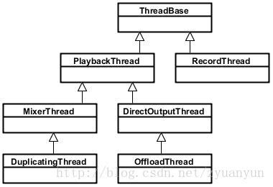

- threadbase: Base class for Playbackthread and Recordthread
- recordthread: Recording thread class, derived by Threadbase
- playbackthread: Playback line Cheng Qi class, derived from Threadbase

- mixerthread: Mixer Playback thread class, derived by playbackthread, responsible for processing identities identified as

Audio_output_flag_primary, Audio_output_flag_fast,

AUDIO_output_flag_deep_buffer audio Stream, Mixerthread can mix multiple track data and then output

- directoutputthread: Direct-output playback thread class, derived from Playbackthread, is responsible for processing audio streams identified as Audio_output_flag_direct, which do not require software mixes, Direct output to an audio device

- duplicatingthread: Copy Playback thread class, derived by mixerthread, responsible for copying audio stream data to other output devices, using scenes such as primary sound card devices, Bluetooth headset devices, USB sound card devices to output simultaneously

- offloadthread: Hard Solution Playback thread class, derived from Directoutputthread, is responsible for processing audio streams identified as Audio_output_flag_compress_offload, This audio stream is not decoded by the software (generally MP3, AAC and other formats of data), need to output to the hardware decoder, by the hardware decoder decoded into PCM data

Playbackthread has an extremely important function threadloop (), when Playbackthread is strongly referenced, Threadloop () will actually run into the loop body and handle audio streaming data related transactions, Threadloop () The approximate process is as follows (in the case of Mixerthread) :

bool AudioFlinger :: PlaybackThread :: threadLoop ()
{

// ......

while (! exitPending ())
{
// ......

{// scope for mLock

Mutex :: Autolock _l (mLock);

processConfigEvents_l ();

// ......

if ((! mActiveTracks.size () && systemTime ()> mStandbyTimeNs)

||
isSuspended ()) {

- put audio hardware into standby after short delay if (shouldStandby_l ()) {

threadLoop_standby ();

mStandby = true;
}

// ......
}

// mMixerStatusIgnoringFastTracks is also updated internally
mMixerStatus = prepareTracks_l (& tracksToRemove);

  - ......
} // mLock scope ends

// ......

if (mBytesRemaining == 0) {
mCurrentWriteLength = 0;
if (mMixerStatus == MIXER_TRACKS_READY) {

- threadLoop_mix () sets mCurrentWriteLength threadLoop_mix ();

}
// ......
}

// ......

if (! waitingAsyncCallback ()) {

- mSleepTimeUs == 0 means we must write to audio hardware if (mSleepTimeUs == 0) {
  - ......
if (mBytesRemaining) {

- FIXME rewrite to reduce number of system calls ret = threadLoop_write ();

lastWriteFinished = systemTime ();

delta = lastWriteFinished - mLastWriteTime; if (ret <0) {

mBytesRemaining = 0; } Else {

mBytesWritten + = ret; mBytesRemaining - = ret; mFramesWritten + = ret / mFrameSize;
}
}
// ......
}

// ......
}

- Finally let go of removed track (s), without the lock held

- since we can not guarantee the destructors will not acquire that

- same lock. This will also mutate and push a new fast mixer
state.

threadLoop_removeTracks (tracksToRemove); tracksToRemove.clear ();

// ......
}

threadLoop_exit ();

if (! mStandby) {
threadLoop_standby ();
mStandby = true;
}

- ......
return false;
}

- The condition of the Threadloop () loop is exitpending () returns FALSE, and if you want to playbackthread the end loop, you can call Requestexit () to request an exit;

- processconfigevents_l (): Handles configuration events; When an event with a configuration change occurs, sendconfigevent_l () needs to be called to notify Playbackthread, so Playbackthread To deal with configuration events in a timely manner; Common configuration events are switching audio paths;

- Check that the standby conditions are met at this point, such as track (mactivetracks.size () = 0), which is not currently active, and turn off the audio hardware device with Threadloop_standby () to save energy consumption;

- preparetracks_l (): Prepare the audio stream and mixer, which is very complex and is not analyzed in detail here, just a list of process points:

- Traverse the Mactivetracks and process the track on the

  - If the track setting is active, check that the track's data is ready; o According to the volume value, format, number of channels, the

sampling rate of audio track and the sampling rate of hardware equipment, the parameters of mixer are configured.

o If the state of the track is paused or stopped, the track is added to the trackstoremove vector;

- Threadloop_mix (): Read all audio stream data with Active state, and the mixer begins to process the data;

- Threadloop_write (): Write the data processed by the mixer to the output stream device;

- Threadloop_removetracks (): Remove all the track from the Trackstoremove from the mactivetracks, so that the track will not be processed in the next loop.

Here's the relationship between Playbackthread and the output flow device: The Playbackthread instance corresponds to the output stream device one by one, for example, Offloadthread only outputs audio data to the Compress_offload device, Mixerthread (with fastmixer) will only output audio data to low_latency devices .

From Audio HAL, we usually see the following 4 output stream devices, each corresponding to a different playback scene:

- primary_out: Primary output stream device for ringtone sound output, corresponding to audio stream identified as Audio_output_flag_primary and an instance of Mixerthread playback thread

- low_latency: Low latency output stream device for sound output with high latency requirements, such as keystroke tones, game background sounds,

corresponding to audio streams identified as Audio_output_flag_fast and an instance of Mixerthread playback threads

- Deep_buffer: Music audio track output stream device for sound output with low latency requirements, such as music, corresponding to an audio stream identified as Audio_output_flag_deep_buffer and an instance of a Mixerthread playback thread

- compress_offload: A hard-to-output streaming device for data output that requires hardware decoding, corresponding to an audio stream identified as Audio_output_flag_compress_offload and a offloadthread Playback Thread Instance

One of these primary_out devices must be declared supported, and the Primary_out device is turned on and the corresponding Mixerthread instance is created when the system starts. Other types of output flow devices are not required to declare support, mainly to see if there is such a capability on the hardware.

There may be a question: Since the primary_out device has been kept open, would not the energy consumption be great Here's a concept:?. The output stream device belongs to a logical device, not a hardware device So even if the output stream device remains open, as long as the hardware device does not work, then it will not affect energy consumption. So when will the hardware device open? The answer is when Playbackthread writes audio data to the output stream device.

The following figure briefly describes the correspondence between Audiotrack, Playbackthread, and output flow devices:
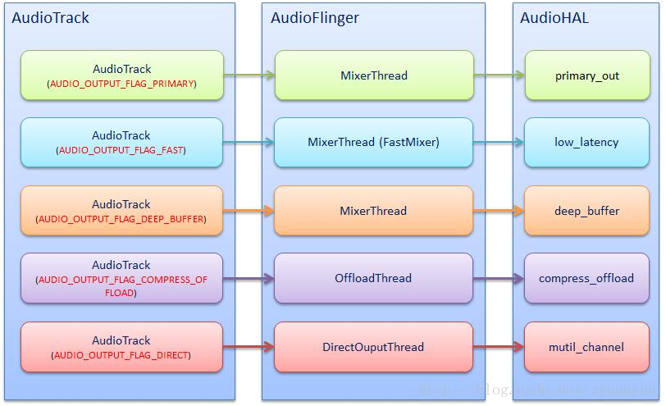

We can say this:. The output stream device determines what type of playbackthread it corresponds to How do you understand that It means that only the type of output stream device is supported, and the playbackthread of that type is only possible to be created?. For example, only hardware decoders are available on the system, and then the compress_offload device is built, and then the music files in MP3 format are created offloadthread the data is output to the compress_offload device; If you do not have a hardware decoder on your hardware, the system should not build a compress_offload device, and when you play a music file in mp3 format, you output the data to another output stream device through Mixerthread.

So it is impossible to do this: the bottom layer does not support the

Compress_offload device, but there is a logo for
Audio_output_flag_compress_offload audio stream sent to Audioflinger That's not

going to happen When the system starts, the support information of the input and
output?. stream device is checked and saved, and when the player plays the mp3
file, it first looks at whether the Compress_offload device is supported and, if so,

does not decode the software and identifies the data directly as Audio_output_flag_
Compress_offload; if not supported, then the software is decoded, and then the
decoded data is identified as Audio_output_flag_deep_buffer, provided that the

Deep_buffer device is supported; if Deep_buffer Device is also not supported, then
the data is identified as Audio_output_flag_primary.

When the system starts, three kinds of output flow devices, Primary_out, low_latency and Deep_buffer, have been opened, and the corresponding mixerthread has been created, at this time Directoutputthread and Offloadthread It is not created until the audio stream identified as audio_output_flag_direct / audio_output_flag_compress_offload requires . output before it begins to create directoutputthread / Offloadthread and open the Direct_out / compress_offload device Please refer to the following code for this point, the comments are very clear:

AudioPolicyManager :: AudioPolicyManager (AudioPolicyClientInterface * clientInterface)
// ......

{
- ......

- mAvailableOutputDevices and mAvailableInputDevices now contain all attached devices

- open all output streams needed to access attached devices
- ......
for (size_t i = 0; i <mHwModules.size (); i ++) {
- ......
- open all output streams needed to access attached devices

- except for direct output streams that are only opened when they are actually

- required by an app.
- This also validates mAvailableOutputDevices list
for (size_t j = 0; j <mHwModules [i] -> mOutputProfiles.size (); j

++)
{

// ......
if ((outProfile-> getFlags () & AUDIO_OUTPUT_FLAG_DIRECT)! = 0)
{

continue;
}
// ......
audio_io_handle_t output = AUDIO_IO_HANDLE_NONE;

status_t status = mpClientInterface-> openOutput (outProfile-> getModuleHandle (),
& Output,

& Config,
& OutputDesc->
mDevice,

address,
& OutputDesc->
mLatency,
outputDesc->
mFlags);

// ......

}

- open input streams needed to access attached devices to validate
- mAvailableInputDevices list
for (size_t j = 0; j <mHwModules [i] -> mInputProfiles.size (); j
++)
{
// ......

status_t status = mpClientInterface-> openInput (inProfile-> getModuleHandle (),
& Input,
& Config,

& InputDesc->
mDevice,
address,

AUDIO_SOURCE_MIC,

AUDIO_INPUT_FLAG_NONE);

// ......
}
}
- ......

updateDevicesAndOutputs ();
}

wherempClientInterface-> openOutput ()will eventually be called toAudioFlinger

- openOutput (): Open the output stream device and create Playbackthread object:

status_t AudioFlinger :: openOutput (audio_module_handle_t module,
audio_io_handle_t * output,
audio_config_t * config,

audio_devices_t * devices,
const String8 & address,
uint32_t * latencyMs,
audio_output_flags_t flags)
{

// ......

Mutex :: Autolock _l (mLock);

sp <PlaybackThread> thread = openOutput_l (module, output, config, * devices, address, flags);
// ......

}

sp <AudioFlinger :: PlaybackThread> AudioFlinger :: openOutput_l (audio_module_handle_t module,

audio_io_handle_t * output,
audio_config_t
* config,

audio_devices_t
devices,

const String8 &
address,

audio_output_flags_t flags)
{
- ......

- Assign globally unique audio_io_handle_t, It is understood that it is played

backThread index number

if (* output == AUDIO_IO_HANDLE_NONE) { * Output = nextUniqueId ();
}
mHardwareStatus = AUDIO_HW_OUTPUT_OPEN;

- ......

- Open toneFrequency device output stream,HAL According layer flags Select Open

related types of output devices stream

AudioStreamOut * outputStream = NULL;

status_t status = outHwDev-> openOutputStream (

- OutputStream, * Output, devices, flags, config, address.string ());

mHardwareStatus = AUDIO_HW_IDLE;

if (status == NO_ERROR) {

PlaybackThread * thread;

if (flags & AUDIO_OUTPUT_FLAG_COMPRESS_OFFLOAD) {

  - AUDIO_OUTPUT_FLAG_COMPRESS_OFFLOAD soundAudio stream, create
OffloadThread Examples

thread = new OffloadThread (this, outputStream, * output, devices, mSystemReady);

ALOGV ( "openOutput_l () created offload output: ID% d thread% p", * output, thread);

} Else if ((flags & AUDIO_OUTPUT_FLAG_DIRECT)
||! IsValidPcmSinkFormat (config-> format)
||! IsValidPcmSinkChannelMask (config-> channel_mask)) {

  - AUDIO_OUTPUT_FLAG_DIRECT soundAudio stream, create

DirectOutputThread Examples

thread = new DirectOutputThread (this, outputStream, * output, devices, mSystemReady);

ALOGV ( "openOutput_l () created direct output: ID% d thread% p", * output, thread);

} Else {

  - otherIdentifies the audio stream, create MixerThread Examples thread = new MixerThread (this, outputStream, * output,

devices, mSystemReady);

ALOGV ( "openOutput_l () created mixer output: ID% d thread% p", * output, thread);

}

- The audio_io_handle_t with PlaybackThread add toKey-value pair vector mPlaybackThreads in

- Key-value pair vector mPlaybackThreads , Because audio_io_handle_t with PlaybackThread is one

- OneCorresponding relationship, so to get a audio_io_handle_t, You can find itcorresponding PlaybackThread

- So I can understand audio_io_handle_t for PlaybackThread Index number mPlaybackThreads.add (* output, thread);

return thread;
}

return 0;

}

3.5. AudioFlinger OffloadThread

When the system starts, three kinds of output flow devices, Primary_out, low_latency and Deep_buffer, have been opened, and the corresponding mixerthread has been created, at this time Directoutputthread and Offloadthread It is not created until the audio stream identified as audio_output_flag_direct / audio_output_flag_compress_offload requires output before it begins to create directoutputthread / Offloadthread and open the Direct_out / compress_offload device.

I do not know if you have any questions here:? Why Directoutputthread and Offloadthread will be treated alone Directouputthread usage is low and understandable, but the use of Offloadthread is still high, so why not let offloadthread / compress_offload devices also go on standby?

To answer this question: we first have to understand what the compress_offload device is and how it differs from other output flow devices First look at a picture.:
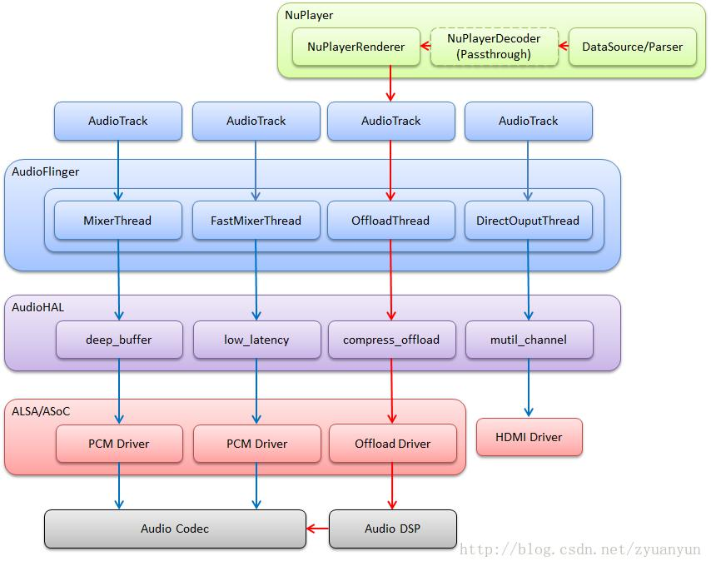

The red one is the offload audio stream, and what is the essential difference between it and other audio streams? Offload audio stream is not nuplayerdecoder decoding (Nuplayerdecoder set the Passthrough mode), so the audio stream data must be sent to the DSP, let the DSP decode it, decoded PCM data sent to Code C output.

Compress_offload device, to put it bluntly, is to drive DSP decoding data, Codec output sound. And DSP to decode the data, first of all, we need to know the data encoding information, such as encoder codec_id, sampling rate sample_rate, channel number channel_mask, bit rate bit_rate and other information, because the DSP did not realize the Datasource / parser department Can not parse the data encoding information, so there has to be "people" to tell it, this "person" is undoubtedly compress_offload device.

The Audiotrack constructor has a offloadinfo parameter, and the parameter prototype is defined as follows:

- * Additional information about compressed streams offloaded to
  - Hardware playback
  - The version and size fields must be initialized by the caller by using
  - One of the constants defined here.
  - /
typedef struct {
uint16_t version; // version of the info structure
uint16_t size; // total size of the structure including version and
size

uint32_t sample_rate; // sample rate in Hz
audio_channel_mask_t channel_mask; // channel mask
audio_format_t format; // audio format
audio_stream_type_t stream_type; // stream type
uint32_t bit_rate; // bit rate in bits per second

int64_t duration_us; // duration in microseconds, -1 if unknown
bool has_video; // true if stream is tied to a video stream
bool is_streaming; // true if streaming, false if local playback
} Audio_offload_info_t;

Nuplayer datasource / parser parsing mp3, FLAC and other files to obtain data encoding information, and in the construction of Audiotrack instances as parameters passed in, Audioflinger will be based on these encoding information to open Compress_offload Equipment.

Come here, do you understand? The encoding information for each MP3 / FLAC file may be different, such as the encoding information for the A.mp3 file is mp3 & 44.1KHZ & 16bit ..., and the encoding information for the B.flac file is flac & 48KHz & 24bit ... When playing a.mp3, Audioflinger opens a configuration for mp3 & 44.1KHz & 16bit ... Compress_offload device, and then play B.flac, you need to shut down the previous compress_offload device and reopen a configuration to flac & 48KHz & 24bit ... Compress_offload device. Therefore, the system does not open the Compress_offload device in advance, only when playing

MP3, FLAC to take clear data encoding information, based on these encoding information to open the Compress_offload device.

Encoding information contains many entries, when switching sound source, whether the encoding information is a little different, all need to reopen the compress_offload device? Can not runtime update information to DSP? In fact, Stagefright and Compress_offload are supporting the running period to update some information, that is, seamless switching, as to what information, depending on the DSP algorithm implementation, interested in in-depth can refer to Sendmetadatatohal () and Compress_ Set_gapless_metadata ().

Finally, attach NuPlayer Offload Playback Initialization Flow, From "Linux Audio Compress Offload Playback and PCM Offload Playback":

- NuPlayer gets the file format metadata based on the type created by the source parser and decoder. For compress offload, DecoderPassThrough is created, causing the software decoder to enter Passthrough mode and not perform decoding.

- NuPlayer calls CanOffloadStream, which in turn calls the APM API isOffloadSupported to

decide if a stream can be offloaded.

- NuPlayer creates a new NuPlayerRenderer, which then creates a new AudioTrack. Based on

the information NuPlayer has received from the APM, it sets the flag FLAG_OFFLOAD_AUDIO, which passes to NuPlayerRenderer.

- AudioTrack then calls getOutput (), which gets the profile information from the APM. The

APM then calls openOutput (), which goes to AudioFlinger. Based on the AUDIO_OUTPUT_FLAG_COMPRESS_OFFLOAD flag previously set by AudioPlayer, AudioFlinger creates the offload thread. AudioFlinger also calls open_output_stream () which goes to the HAL. The HAL then creates the offload callback thread used to notify the write and drain completion events.

- AudioTrack creates the track to be used for this stream.

- NuPlayerRenderer issues a start command to AudioSink, which then calls start_output_stream (). The HAL sends the appropriate mixer control to the back-end (BE) platform driver to configure the output device.

- The HAL opens the Compress driver and sends the codec and stream parameters to the

Compress driver though the IOCTL sndrv_compress_set_params. The Compress driver opens an ASM session accordingly and requests the ASM driver to allocate the buffers to is used for th is session.
3.6. Audioflinger Audio Stream Management

From the diagram of Audiotrack, playbackthread, output flow devices, we see Audiotrack sending audio stream data into the corresponding Playbackthread, then the application process wants to control these audio streams, such as starting to play start (), stop playing Stop (), pause playback pause (), what to do? Note the application process and Audioflinger are not on a single process.This requires Audioflinger to provide audio streaming management capabilities, as well as a set of communication interfaces that allow the application process to control the audio flow state in the Audioflinger across processes (the communication interface refers to the description in the next chapter, not for a while).

Audioflinger Audio Stream Management by Audioflinger :: P laybackthread :: track Implementation, track and Audiotrack is a one-to-one relationship, after the creation of a audiotrack, then Audioflinger will create a track corresponding to it; Playbackthread and Audiotrack / track are a one-to-many relationship, and a playbackthread can hang multiple track.

Specifically: After Audiotrack is created, Audiopolicymanager finds the corresponding output stream device and playbackthread based on Audiotrack output identification and stream type (if not found, The system opens the corresponding output stream device and creates a new Playbackthread), and then create a track and hang it under this playbackthread.

Playbackthread has two private member vectors associated with this strong:

- mTracks:That PlaybackThread All created Track Were added to saveTo thisthe amountin

- mActiveTracks: Only you need to play (already setup ACTIVE shapeState) Track Added toThis vector;PlaybackThread It will be fromFind all the set vector ACTIVE shapeStates Track, TheThese ones

Track After the data is written to the mixOutput stream providedEquipment

soundFrequency three most commonly used flow control interfaces:

- AudioFlinger :: PlaybackThread :: Track :: start: Start playing: theThat Track Put ACTIVE shapeState, then added to the mActiveTracks

Vector, the lasttransfer AudioFlinger :: PlaybackThread :: broadcast_l () inform PlaybackThread There are circumstanceschange

- AudioFlinger :: PlaybackThread :: Track :: stop: Stop playing: theThat Track Put STOPPED shapeState, the last call AudioFlinger ::

PlaybackThread :: broadcast_l () inform PlaybackThread There are circumstanceschange

- AudioFlinger :: PlaybackThread :: Track :: pause:Pause Playback: The

Track Put PAUSING shapeState, the last call AudioFlinger :: PlaybackThread :: broadcast_l () inform PlaybackThread There are circumstanceschange

AudioFlinger :: PlaybackThread :: threadLoop ()Circumstances have learnedAfter the change, call prepareTracks_l () Re quasiPreparation and audio stream mixer:ACTIVE shapeStates Track Added to mActiveTracksIn addition the Track It will be from mActiveTracks On removing it, and then re-quasiEquipment AudioMixer.

canSee these three audio streamsThe control interface is verySimple, mainly to set about Track The shapeState, then send an event notification PlaybackThread On the line, complexIn miscellaneous processing AudioFlinger :: PlaybackThread :: threadLoop () bingo.

3.7. AudioFlinger MixerOfficeReason

// TODO: ...

- AudioTrack Examples of recordbuild

Now we begin to analyze AudioTrack ofCreation process, special attention AudioTrack versus AudioFlinger How to buildContact for AudioTrack versus AudioFlinger crossHow to change the data anonymous shared memory allocation.

4.1. AudioTrack & AudioFlinger Relatedclass

First look AudioTrack & AudioFlinger ofClass diagram, haircut AudioFlinger MianClasses and their relationship,AudioTrack versus AudioFlinger ItLinks between, will be behind the graph context to analyze.
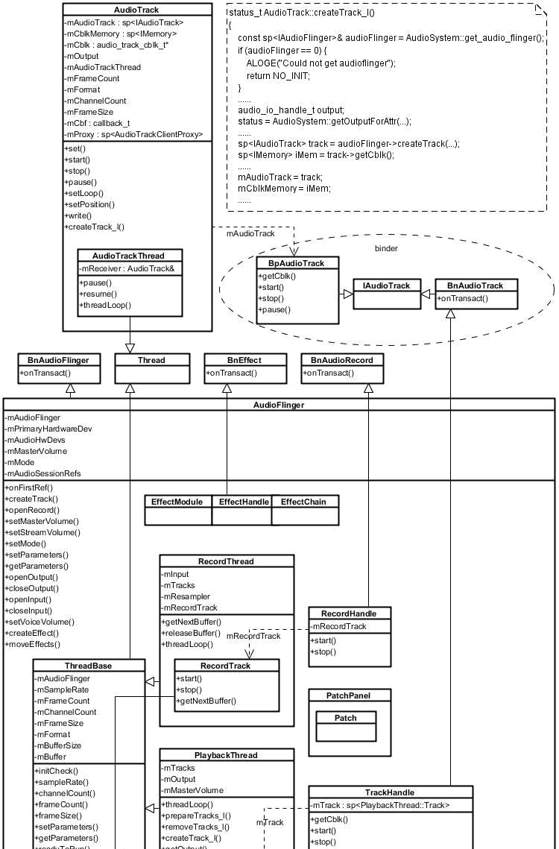

- AudioFlinger :: PlaybackThread: PlaybackThread base class, the audio stream corresponding to the identified different output of different types of PlaybackThread Examples (divided into four categories:MixerThread,DirectOutputThread,DuplicatingThread,OffloadTh

read),specificsee3.4. AudioFlinger PlaybackRecord ThreadsmallFestival, all

of PlaybackThread Examples will be added to

AudioFlinger.mPlaybackThreads Vector;This vector is
defined:DefaultKeyedVector <audio_io_handle_t, sp <PlaybackThread>>

mPlaybackThreads;,cansee audio_io_handle_t With PlaybackThread It is elevenCorresponding to the known audio_io_handle_t Able to findcorresponding PlaybackThread;audio_io_handle_t increate

PlaybackThread When assigned by the system, this value is globally uniqueof

- AudioFlinger :: PlaybackThread :: Track:soundFrequency flow management class, create an anonymous shared memory for AudioTrack versus AudioFlinger ItData exchange between (convenience, this anonymous shared memory, after all, simply referred to FIFO),withImplementing start (),stop (),pause () And other audioCommon pilot flow control means; Note, a plurality of Track Registered to the same object may have a

PlaybackThread (Especiallyfor MixerThread For, a MixerThread

Hanging more often Track Object), which more Track Objects are added to

PlaybackThread.mTracks VectorUnified managementReason

- AudioFlinger :: TrackHandle:Track The audio stream object is only responsible for business management, foreign and does not provide cross-process Binder Call interface, and the application process and the need to control the audio stream, you need a proxy object Track CrossProcess communication, this role is TrackHandle,AudioTrack throughOver it Track crossmutual

- AudioTrack:Android soundA system to provide both frequency API Class is responsible for outputting the audio data stream; each audio stream corresponds to a AudioTrack Example, different output identification AudioTrack It will match to a different AudioFlinger :: PlaybackThread;AudioTrack versus AudioFlinger :: PlaybackThread ItInter through FIFO To payExchange audio data,AudioTrack Yes FIFO RawProducers,AudioFlinger :: PlaybackThread Yes FIFO EliminatefeeBy

- AudioTrack :: AudioTrackThread:dataTransmission mode

TRANSFER_CALLBACK When you need to create the thread by calling audioCallback returnTransfer function from the initiative to obtain data at the user process and to fill FIFO On; dataTransmission mode

TRANSFER_SYNC When you do not need to create this thread, because user processes will continue to call AudioTrack.write () Padding data to FIFO;dataTransmission mode TRANSFER_SHARED When, you do not need to create this thread, because an anonymous user process creates a shared memory, and the audio data to be played this anonymous one-time copy to the shared memoryThe

- IAudioTrack:IAudioTrack Yeslink AudioTrack versus AudioFlinger ofBridge; it AudioTrack End ofThe object is BpAudioTrack,in AudioFlinger End ofThe object is BnAudioTrack,FromFigure easy to see,AudioFlinger :: TrackHandle Inherited from BnAudioTrack,and AudioFlinger :: TrackHandle happen toAudioFlinger :: PlaybackThread :: Track AgentsObject, AudioTrack get IAudioTrack After instance, you can call IAudioTrack The interface AudioFlinger :: PlaybackThread :: Track crossmutual

audio_io_handle_t:

Here again elaborate on audio_io_handle_t,it is AudioTrack / AudioRecord / AudioSystem,AudioFlinger,AudioPolicyManager ItAn important link between the points.3.4. AudioFlinger PlaybackRecord ThreadsmallFestival AudioFlinger ::

openOutput_l () NoteBuddhism in general description of its origin and its role, now

under the review: When you open the device and create an output stream

PlaybackThread When the system is assigned a globally unique value as

audio_io_handle_tAnd put audio_io_handle_t with PlaybackThread add toKey-

value pair vector mPlaybackThreads , Because audio_io_handle_t with

PlaybackThread It is elevenCorresponding relationship, so to get a

audio_io_handle_tCan passCalendar of key vector mPlaybackThreads Find

itcorresponding PlaybackThread,canSimple to understand audio_io_handle_t for

PlaybackThread The index number orThread id. due to audio_io_handle_t

have PlaybackThread Index characteristics,Want to get the application process

PlaybackThread Some informationThen only need to pass the corresponding

audio_io_handle_t It can be. E.g AudioFlinger :: format (audio_io_handle_t

output),this is AudioFlinger Of a serviceService Interface,useA user process can

be obtained through the interface PlaybackThread Configure soundFrequency

format:

audio_format_t AudioFlinger :: format (audio_io_handle_t output) const {
Mutex :: Autolock _l (mLock);

// checkPlaybackThread_l () according toIncoming audio_io_handle_t,FromKey-value pair vector

- mPlaybackThreads Find itcorresponding PlaybackThread PlaybackThread * thread = checkPlaybackThread_l (output); if (thread == NULL) {

ALOGW ( "format () unknown thread% d", output); return AUDIO_FORMAT_INVALID;

}
return thread-> format ();
}

AudioFlinger :: PlaybackThread * AudioFlinger :: checkPlaybackThread_l
(audio_io_handle_t output) const
{
return mPlaybackThreads.valueFor (output) .get ();
}

4.2. AudioTrack structureLiveJourney

When IThey construct a AudioTrack Examples of when (to MODE_STREAM / TRANSFER_SYNC modeFor example, which is the most commonly used modes, and this time sharedBuffer Is empty), the system what happened? Described under the

general process:

- in case cbf(audioCallback returnTransfer function) is not empty, create

AudioTrackThread Threading audioCallback returnTransfer function (MODE_STREAM modeTime,cbf Is empty);

- according to streamType(flowTypes of),flags(Output identification) and other parameters call AudioSystem :: getOutputForAttr ();After a series of calls, enter AudioPolicyManager :: getOutputForDevice ():

- in caseOutput identifies a set

AUDIO_OUTPUT_FLAG_COMPRESS_OFFLOAD or AUDIO_OUTPUT_FLAG_DIRECT, The mostFinal call

AudioFlinger :: openOutput () turn onAn output device corresponding to the identifier of the output stream and creates corresponding

PlaybackThread,saveThat PlaybackThread corresponding audio_io_handle_t give AudioTrack;

- in caseOutput identifies the other type, then a stream output device based on policy choices and PlaybackThreadAnd saveThat

PlaybackThread corresponding audio_io_handle_t give

AudioTrack;Do not forget3.4. AudioFlinger PlaybackRecord

ThreadsmallIt is mentioned: when the system starts, it has been opened

primary_out,low_latency,deep_buffer The three output streams apparatus, and creates the corresponding PlaybackThread The;

- throughLive Binder mechanismtransfer AudioFlinger :: createTrack ()(note step2 in AudioTrack AlreadyThrough to get a audio_io_handle_t , And thisWhen this audio_io_handle_t Passed to createTrack ()):

o

o

o

according toIncoming audio_io_handle_t Find itcorresponding PlaybackThread;

PlaybackThread Create a new soundFrequency Flow Management Objects Track;Track structureWhen an anonymous shared memory will be allocated for AudioFlinger versus AudioTrack Data deliveryIn other buffer (FIFO) And its controlPiece(audio_track_cblk_t),andCreate

AudioTrackServerProxy Objects (PlaybackThread We will use it from FIFO Be made onPosition of the read data);

Finally, a new Track ThroughNews agency TrackHandle,and

IAudioTrack MakeFor the return value to

AudioTrack(TrackHandle,BnAudioTrack,BpAudioTrack,IAudioTr

ack RelationshipSee above a bar);

- throughLive IAudioTrack Interface, get AudioFlinger middle FIFO controlPiece(audio_track_cblk_t), Which againCalculated FIFO The first address;

- Create AudioTrackClientProxy Objects (AudioTrack We will use it from

FIFO Made available on emptyLocation between);

AudioTrack Thereby establishing and AudioFlinger AllContact Work:

•

•

•

throughLive IAudioTrack Interface can be controlledState of the track, e.g. start,stop,pause

holdWriting the data to FIFO on,Achieve continuous audio broadcastput throughLive audio_io_handle_tYou can find itcorresponding PlaybackThread,therebyThe query PlaybackThread Related information, such as theSetting sampling rates, format, etc.Wait

structure 1 More AudioTrack Instance, theAudioFlinger There will be 1 More PlaybackThread Example,1 More Track Example,1 More TrackHandle Example,1 More AudioTrackServerProxy Example,1 Piece FIFO Withcorrespond.

When the sameWhen constructing 1 MoreAudioTrack with

AUDIO_OUTPUT_FLAG_PRIMARY,1 MoreAudioTrack with AUDIO_OUTPUT_FLAG_FAST,3 MoreAudioTrack with AUDIO_OUTPUT_FLAG_DEEP_BUFFER,1 MoreAudioTrack with AUDIO_OUTPUT_FLAG_COMPRESS_OFFLOAD,1 MoreAudioTrack with

AUDIO_OUTPUT_FLAG_DIRECTWhen (in fact,Android soundFrequency policy does not allow this situation),AudioFlinger own PlaybackThread,Track,TrackHandle Examples shown below:
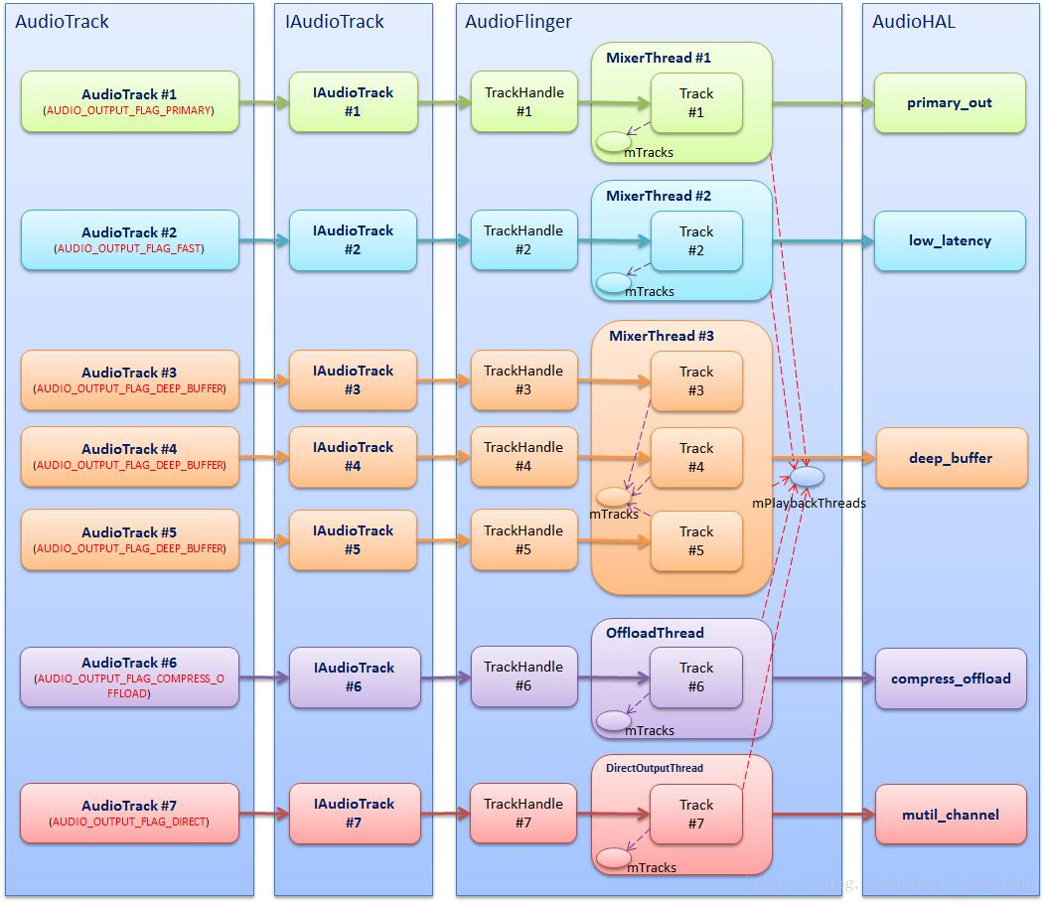

Finally, attach the relevant GenerationProcess code analysis, my intention is not much paste code, but the code is not always felt something missing, and here I try to streamline the code, extracting the trunk, ignore the details.

AudioTrack :: AudioTrack (

audio_stream_type_t streamType, // soundFlow Type Frequency: As Music,Voice-Call,DTMF,Alarm and many more

uint32_t sampleRate, // CollectionSample rate: as 16KHz,44.1KHz,48KHz and many more

audio_format_t format, // soundVideo format: If PCM,MP3,AAC and many more

audio_channel_mask_t channelMask, // Number of channels: as Mono(Mono),Stereo(Binaural)

const sp <IMemory> & sharedBuffer, // Shared memoryBuffer: The data model is MODE_STATIC In use, a data pattern MODE_STREAM When empty

audio_output_flags_t flags, // Output flag, see AUDIO_OUTPUT_FLAG description

callback_t cbf, // returnTransfer function

void * user, // returnParameter transfer function uint32_t notificationFrames,
int sessionId,

transfer_type transferType, // dataTransport Type const audio_offload_info_t * offloadInfo,
int uid,
pid_t pid,

const audio_attributes_t * pAttributes, bool doNotReconnect)

- MStatus (NO_INIT), mIsTimed (false),

mPreviousPriority (ANDROID_PRIORITY_NORMAL), mPreviousSchedulingGroup (SP_DEFAULT), mPausedPosition (0),
mSelectedDeviceId (AUDIO_PORT_HANDLE_NONE)
{
mStatus = set (streamType, sampleRate, format, channelMask,

0 / * frameCount * /, flags, cbf, user, notificationFrames, sharedBuffer, false / * threadCanCallJava * /, sessionId,

transferType, offloadInfo,
uid, pid, pAttributes, doNotReconnect);
}

status_t AudioTrack :: set (

audio_stream_type_t streamType,
uint32_t sampleRate,
audio_format_t format,

audio_channel_mask_t channelMask,
size_t frameCount,
audio_output_flags_t flags,
callback_t cbf,
void * user,

uint32_t notificationFrames,
const sp <IMemory> & sharedBuffer,
bool threadCanCallJava,
int sessionId,
transfer_type transferType,

const audio_offload_info_t * offloadInfo,
int uid,
pid_t pid,

const audio_attributes_t * pAttributes, bool doNotReconnect)

{

- Parameter format legitimacyChecking the track initialization volume

- in case cbf Is not empty,create AudioTrackThread Threading audioCallback

returnTransfer function

if (cbf! = NULL) {
mAudioTrackThread = new AudioTrackThread (* this, threadCanCallJava);

mAudioTrackThread-> run ( "AudioTrack", ANDROID_PRIORITY_AUDIO, 0 /
- stack * /);
  - thread begins in paused state, and will not reference us until
start ()
}

// create the IAudioTrack

status_t status = createTrack_l ();

// ......

}

status_t AudioTrack :: createTrack_l ()
{

// Obtain IAudioFlinger,throughLive binder request AudioFlinger clothesBusiness

const sp <IAudioFlinger> & audioFlinger = AudioSystem ::
get_audio_flinger ();
if (audioFlinger == 0) {

ALOGE ( "Could not get audioflinger"); return NO_INIT;

}

- ......

- AudioSystem :: getOutputForAttr () After a series of calls, enter AudioPolicyManager :: getOutputForDevice ()

- in caseOutput identifies a set AUDIO_OUTPUT_FLAG_COMPRESS_OFFLOAD or

AUDIO_OUTPUT_FLAG_DIRECT,

- Then the mostFinal call AudioFlinger :: openOutput () turn onIt outputs the

output stream corresponding to the identifier associated with the device and create

- PlaybackThread,saveThat PlaybackThread corresponding audio_io_handle_t give AudioTrack;

- in caseOutput identifies the other type, then a stream output device based on policy choices and PlaybackThreadAnd saveThat

- PlaybackThread corresponding audio_io_handle_t give AudioTrack

audio_io_handle_t output;
status = AudioSystem :: getOutputForAttr (attr, & output,
(Audio_session_t) mSessionId, &

streamType, mClientUid,
mSampleRate, mFormat,
mChannelMask,
mFlags, mSelectedDeviceId,
mOffloadInfo);

- ......

- to AudioFlinger issue createTrack request

sp <IAudioTrack> track = audioFlinger-> createTrack (streamType,

mSampleRate,
mFormat,
mChannelMask,

& Temp,
& TrackFlags,
mSharedBuffer,
output,
tid,
& MSessionId,
mClientUid,

& Status);
- ......

- AudioFlinger create Track When an object is assigned a FIFO,Get here FIFO

controlPiece

sp <IMemory> iMem = track-> getCblk (); if (iMem == 0) {

ALOGE ( "Could not get control block"); return NO_INIT;

}

- Anonymous shared memory first address

void * iMemPointer = iMem-> pointer (); if (iMemPointer == NULL) {

ALOGE ( "Could not get control block pointer"); return NO_INIT;

}

mAudioTrack = track; // save AudioFlinger :: PlaybackThread :: Track AgentsObjects IAudioTrack

mCblkMemory = iMem; // Save anonymous shared memory first address

- controlBlock is located AudioFlinger The first part-anonymous shared memory audio_track_cblk_t * cblk = static_cast <audio_track_cblk_t *>
(iMemPointer);

mCblk = cblk;

mOutput = output; // Save returned audio_io_handle_tUse it can be foundcorresponding PlaybackThread

- ......

- update proxy
if (mSharedBuffer == 0) {

- when mSharedBuffer Is empty, meaning that track data mode

MODE_STREAMThencreate AudioTrackClientProxy Objects mStaticProxy.clear ();

mProxy = new AudioTrackClientProxy (cblk, buffers, frameCount, mFrameSize);
} Else {

  - when mSharedBuffer Is not empty, it means soundTrack data mode

MODE_STATICThencreate StaticAudioTrackClientProxy Objects

mStaticProxy = new StaticAudioTrackClientProxy (cblk, buffers,
frameCount, mFrameSize);
mProxy = mStaticProxy;
}

// ......
}

Audioflinger :: createtrack (), as the name implies, creates a track object that will be used for the control of the audio stream:

sp <IAudioTrack> AudioFlinger :: createTrack (
audio_stream_type_t streamType,
uint32_t sampleRate,
audio_format_t format,
audio_channel_mask_t channelMask,

size_t * frameCount,
IAudioFlinger :: track_flags_t * flags, const sp <IMemory> & sharedBuffer, audio_io_handle_t output, pid_t tid,

int * sessionId,
int clientUid,
status_t * status)

{
sp <PlaybackThread :: Track> track;
sp <TrackHandle> trackHandle;
sp <Client> client;
status_t lStatus;

int lSessionId;

// ......

{

Mutex :: Autolock _l (mLock);

- according toPassed to the audio_io_handle_t,turn upcorresponding

PlaybackThread

PlaybackThread * thread = checkPlaybackThread_l (output); if (thread == NULL) {

ALOGE ( "no playback thread found for output handle% d",
output);

lStatus = BAD_VALUE; goto Exit;

}

- ......

- in PlaybackThread onAudio stream to create a managed object Track track = thread-> createTrack_l (client, streamType, sampleRate,

format,

channelMask, frameCount, sharedBuffer, lSessionId, flags, tid, clientUid, & lStatus);
// ......

setAudioHwSyncForSession_l (thread, (audio_session_t) lSessionId);

}

- ......

- create Track ThroughNews agency TrackHandle And return it trackHandle = new TrackHandle (track);

Exit:

- Status = lStatus; return trackHandle;
}

sp <AudioFlinger :: PlaybackThread :: Track> AudioFlinger :: PlaybackThread

:: createTrack_l (

const sp <AudioFlinger :: Client> & client, audio_stream_type_t streamType, uint32_t sampleRate,
audio_format_t format,

audio_channel_mask_t channelMask,
size_t * pFrameCount,
const sp <IMemory> & sharedBuffer,

int sessionId,
IAudioFlinger :: track_flags_t * flags,
pid_t tid,
int uid,

status_t * status)
{
size_t frameCount = * pFrameCount;
sp <Track> track;
status_t lStatus;

bool isTimed = (* flags & IAudioFlinger :: TRACK_TIMED) = 0!;

// ......

{// scope for mLock
Mutex :: Autolock _l (mLock);

// ......

if (! isTimed) {

- create Track, And so will look at Track Constructors do someWhat track = new Track (this, client, streamType, sampleRate,

format,

channelMask, frameCount, NULL, sharedBuffer, sessionId, uid, * flags, TrackBase ::
TYPE_DEFAULT);
} Else {

  - create TimedTrack,Timestamped Track?Here do not get to the bottom

track = TimedTrack :: create (this, client, streamType, sampleRate, format,

channelMask, frameCount, sharedBuffer, sessionId, uid);
}

- ......

- TheCreated Track add to mTracks Vector, convenience PlaybackThread

Unified Management

mTracks.add (track);

// ......
}

lStatus = NO_ERROR;

Exit:

- Status = lStatus; return track;
}

- ------------------------------------------------ -----------------------
-----

- It is as follows TrackHandle On behalf of the relevantCode, you can

see,TrackHandle itsReal is a shell, is Track package ofclass

- all TrackHandle Interfaces areTune to Track of

- Google So why should one?Track Yes PlaybackThread Internal use, inappropriateForeign exposure, but the application process

- And indeedYou need to control the solid state audio stream(start,stop,pause), So it takesOne way to achieve such

AudioFlinger :: TrackHandle :: TrackHandle (const sp <AudioFlinger ::
PlaybackThread :: Track> & track)
- BnAudioTrack (), mTrack (track)

{
}

AudioFlinger :: TrackHandle :: ~ TrackHandle () {
- just stop the track on deletion, associated resources
- will be freed from the main thread once all pending buffers have
- been played. Unless it's not in the active track list, in which
- case we free everything now ...
mTrack-> destroy ();
}

sp <IMemory> AudioFlinger :: TrackHandle :: getCblk () const { return mTrack-> getCblk ();
}

status_t AudioFlinger :: TrackHandle :: start () { return mTrack-> start ();

}

void AudioFlinger :: TrackHandle :: stop () { mTrack-> stop ();
}

void AudioFlinger :: TrackHandle :: flush () { mTrack-> flush ();

}

void AudioFlinger :: TrackHandle :: pause () { mTrack-> pause ();
}

- ------------------------------------------------ -----------------------
-----

lastly, IThey look Track StructureProcess, the main analysis data FIFO And its controlHow block is allocated:

AudioFlinger :: PlaybackThread :: Track :: Track ( PlaybackThread * thread,
const sp <Client> & client,

audio_stream_type_t streamType,
uint32_t sampleRate,
audio_format_t format,

audio_channel_mask_t channelMask,
size_t frameCount,

void * buffer,
const sp <IMemory> & sharedBuffer,
int sessionId,

int uid,
IAudioFlinger :: track_flags_t flags,
track_type type)

- TrackBase (thread, client, sampleRate, format, channelMask, frameCount,

(! SharedBuffer = 0) sharedBuffer-> pointer ():? Buffer, sessionId, uid, flags, true / * isOut * /,

(Type == TYPE_PATCH) (buffer == NULL ALLOC_LOCAL:? ALLOC_NONE):? ALLOC_CBLK,
type),
mFillingUpStatus (FS_INVALID),

- mRetryCount initialized later when needed mSharedBuffer (sharedBuffer),

mStreamType (streamType), mName (-1), // see note below mMainBuffer (thread-> mixBuffer ()), mAuxBuffer (NULL),

mAuxEffectId (0), mHasVolumeController (false), mPresentationCompleteFrames (0),

mFastIndex (-1), mCachedVolume (1.0), mIsInvalid (false), mAudioTrackServerProxy (NULL), mResumeToStopping (false), mFlushHwPending (false)

{
// client == 0 implies sharedBuffer == 0

ALOG_ASSERT (! (Client == 0 && sharedBuffer = 0)!);

ALOGV_IF (sharedBuffer = 0,! "SharedBuffer:% p, size:% d", sharedBuffer-> pointer (),
sharedBuffer-> size ());

- an examination FIFO controlPiece(audio_track_cblk_t) Whether to allocate Well, on behalf of the aboveCode not assigned audio_track_cblk_t

- Therefore only be constructed TrackBase When assigned, and then wait for the

next look TrackBase Constructor

if (mCblk == NULL) {
return;
}

if (sharedBuffer == 0) {

// dataTransmission mode MODE_STREAM mode,Create AudioTrackServerProxy

Objects

- PlaybackThread Will holdContinued use it from FIFO Be made onRead

location data

mAudioTrackServerProxy = new AudioTrackServerProxy (mCblk, mBuffer, frameCount,

! MFrameSize, isExternalTrack (), sampleRate);
} Else {

  - dataTransmission mode MODE_STATIC mode,Create
StaticAudioTrackServerProxy Objects

mAudioTrackServerProxy = new StaticAudioTrackServerProxy (mCblk, mBuffer, frameCount,

mFrameSize);
}
mServerProxy = mAudioTrackServerProxy;

- for Track Assign a name,AudioMixer It will be based TrackName turn

upcorresponding Track

mName = thread-> getTrackName_l (channelMask, format, sessionId); if (mName <0) {

ALOGE ( "no more track names available"); return;
}

// ......
}

AudioFlinger :: ThreadBase :: TrackBase :: TrackBase (
ThreadBase * thread,
const sp <Client> & client,

uint32_t sampleRate,
audio_format_t format,
audio_channel_mask_t channelMask,
size_t frameCount,
void * buffer,

int sessionId,
int clientUid,
IAudioFlinger :: track_flags_t flags,
bool isOut,
alloc_type alloc,

track_type type)
: RefBase (),
mThread (thread),
mClient (client),
mCblk (NULL),

- mBuffer mState (IDLE), mSampleRate (sampleRate), mFormat (format), mChannelMask (channelMask), mChannelCount (isOut?

audio_channel_count_from_out_mask (channelMask): audio_channel_count_from_in_mask (channelMask)),

mFrameSize (audio_is_linear_pcm (format)?
mChannelCount * audio_bytes_per_sample (format): sizeof
(int8_t)),
mFrameCount (frameCount),
mSessionId (sessionId),
mFlags (flags),
mIsOut (isOut),

mServerProxy (NULL),
mId (android_atomic_inc (& nextTrackId)),
mTerminated (false),
mType (type),
mThreadIoHandle (thread-> id ())

{
  - ......

  - ALOGD ( "Creating track with% d buffers @% d bytes", bufferCount, bufferSize);

size_t size = sizeof (audio_track_cblk_t);

size_t bufferSize = (buffer == NULL roundup (frameCount): frameCount?)

- mFrameSize;
if (buffer == NULL && alloc == ALLOC_CBLK) {

- This one size Will be allocated size of the anonymous shared memory

- Equal controlBlock size (sizeof (audio_track_cblk_t)Plus data FIFOthe size of(bufferSize)

- Will be seenThis memory structure, to understand the significance of this

allocation

size + = bufferSize;

}

if (client! = 0) {

- Assigned aAnonymous shared memory block

mCblkMemory = client-> heap () -> allocate (size); if (mCblkMemory == 0 ||

(MCblk = static_cast <audio_track_cblk_t *> (mCblkMemory-> pointer ())) == NULL) {
ALOGE ( "not enough memory for AudioTrack size =% u", size);
client-> heap () -> dump ( "AudioTrack");

mCblkMemory.clear ();
return;
}
} Else {
  - this syntax avoids calling the audio_track_cblk_t constructor
twice
mCblk = (audio_track_cblk_t *) new uint8_t [size];
  - assume mCblk! = NULL
}

- construct the shared structure in-place. if (mCblk! = NULL) {

  - this is C ++ of placement new(PositioningCreate Object) syntax:new (@BUFFER) @CLASS ();

  - It can be configured in a specific memory locationObjects
  - Here, on an anonymous shared memory constructs a first address

audio_track_cblk_t Objects

// such AudioTrack versus AudioFlinger CanVisit this audio_track_cblk_t

Objects of

new (mCblk) audio_track_cblk_t ();

// Data are assigned as follows FIFOIt will be used AudioTrack versus AudioFlinger Data deliverychange

switch (alloc) {

// ......
case ALLOC_CBLK:

- clear all buffers if (buffer == NULL) {

  - dataTransmission mode MODE_STREAM / TRANSFER_SYNC , The data

FIFO Allocation

  - data FIFO The first addressAgainst the control block

(audio_track_cblk_t)after that

// | |
// | -------------------> mCblkMemory <--------------------
- |
// | |
// + -------------------- + -------------------------- ----

------ +
// | audio_track_cblk_t | Buffer |
// + -------------------- + -------------------------- ----
------ +
// ^ ^

// | |
// mCblk mBuffer

mBuffer = (char *) mCblk + sizeof (audio_track_cblk_t); memset (mBuffer, 0, bufferSize);
} Else {

  - dataTransmission mode MODE_STATIC / TRANSFER_SHARED When pointed directly sharedBuffer

  - sharedBuffer YesAnonymous application process allocation of

shared memory, the application process has been a one-time data

- Wrote sharedBuffer coming,AudioFlinger Directly fromRead here

// + -------------------- + ------------------------- + ---
------- +
// | audio_track_cblk_t | | sharedBuffer |
// + -------------------- + ------------------------- + ---
------- +

- ^ ^
- | |

- mCblk mBuffer mBuffer = buffer;
}

break;
- ......
}

- ......

}
}

5. Audiotrack Data Write

After the Audiotrack instance is constructed, the application can then write audio data As previously described:. Audiotrack and Audioflinger are producer-consumer relationships:

- audiotrack: Audiotrack finds a piece of free space in FIFO, writes the user's incoming audio data to this free space, and then updates the write location (for Audiofinger, it means more readable data on FIFO) If the amount of data passed in by the user is greater than the available space, split the user's incoming data multiple times into FIFO (Audiotrack and Audioflinger are different processes, and Audioflinger is constantly reading the data, so FIFO The free space is constantly changing)

- Audioflinger: Audioflinger finds a readable block of data in FIFO, copies the readable data to the destination buffer, and then updates the read position (for Audiotrack, it means more free space on FIFO) If the amount of readable data on FIFO is smaller than expected , multiple reads can accumulate to the expected amount of data (Audiotrack and Audioflinger are different processes, audiotrack are also constantly writing data, so FIFO The amount of readable data is constantly changing)

In the above process, if audiotrack always produce data in a timely manner, and Audioflinger can consume this data in a timely manner, then the whole process will be very harmonious, but the system may be abnormal, the following status occurs:

- Block: audioflinger does not read the readable data on FIFO for a long time, so that audiotrack can not get free space for a long time, can not write data, the root cause of this situation is mostly the underlying driver blocking abnormal, resulting in audioflinger Unable to continue writing data to hardware devices, Audioflinger itself is not wrong

- The speed at which Underrun: audiotrack writes data does not keep pace with the speed at which Audioflinger reads data, making it impossible for

Audioflinger to obtain the expected amount of data in a timely manner, reflecting the fact that the consequence is that the sound is intermittent The root cause of this situation is that the application can not write data in time or the buffer allocation is too small, and the audiotrack itself is not wrong; Audioflinger is fault-tolerant for this: When Underrun is found, it first falls into a short period of sleep and does not rush to read the data. Get the app to prepare more data (if one day the app's buddy realizes that his mistake turned out to be silently paid by the underlying brother, will it be moved to cry ^ _ ^)

5.1. Audiotrack Write Data Flow

Let's take a look at the code Audiotrack writes the data, the process is simple: Obtainbuffer () finds an available interval in FIFO, memcpy () copies the user's incoming audio data to this available interval, releasebuffer () updates the write location.

ssize_t AudioTrack :: write (const void * buffer, size_t userSize, bool

blocking)
{
if (mTransfer! = TRANSFER_SYNC) {

return INVALID_OPERATION;
}

if (isDirect ()) {
AutoMutex lock (mLock);

int32_t flags = android_atomic_and (
- (CBLK_UNDERRUN | CBLK_LOOP_CYCLE |
CBLK_LOOP_FINAL | CBLK_BUFFER_END),
- MCblk-> mFlags);
if (flags & CBLK_INVALID) {
return DEAD_OBJECT;
}
}

if (ssize_t (userSize) <0 || (buffer == NULL && userSize! = 0)) {

// Sanity-check: user is most-likely passing an error code, and it
would

- make the return value ambiguous (actualSize vs error). ALOGE ( "AudioTrack :: write (buffer =% p, size =% zu (% zd)",
buffer, userSize, userSize);

return BAD_VALUE;
}

size_t written = 0;
Buffer audioBuffer;

while (userSize> = mFrameSize) {

- The amount of data a single frame frameSize = channelCount * bytesPerSample

- For two-channel,16Bit miningKind of audio data, theframeSize = 2 * 2 =

4 (bytes)

- useHouseholds incoming data frames frameCount = userSize / frameSize audioBuffer.frameCount = userSize / mFrameSize;

- obtainBuffer () From FIFO Get on aBlock available interval status_t err = obtainBuffer (& audioBuffer,
  - Blocking & ClientProxy :: kForever: & ClientProxy ::
kNonBlocking);
if (err <0) {
if (written> 0) {
break;
}

if (err == TIMED_OUT || err == -EINTR) { err = WOULD_BLOCK;
}

return ssize_t (err);
}

- toWrite Yes FIFO Available areaThe size of the room, possibly more than userSize(useHouseholds incoming data size) is smaller

- So withHouseholds incoming data may be split into multiple copies FIFO on

- note:AudioTrack with AudioFlinger It is differentprocess,AudioFlinger

withWhen are constantly

- Consumption data, FIFO Available areaInter is constantly changing size_t toWrite = audioBuffer.size;

memcpy (audioBuffer.i8, buffer, toWrite); // The useUser data is copied

into FIFO Available areabetween

buffer = ((const char *) buffer) + toWrite; // Not beatTony's location

data

userSize - = toWrite; // Not beatThe size of the data shellfish written + = toWrite; // Copy has beenThe size of the data shellfish

- releaseBuffer () Update FIFO Write position

- for AudioFinger ComeHe said means FIFO There may be more onRead Data releaseBuffer (& audioBuffer);

}

if (written> 0) {
mFramesWritten + = written / mFrameSize;
}

return written;
}

5.2. Audioflinger Read Data Flow

The process of Audioflinger consumption data is slightly more complex,3.4. AudioFlingerPlaybackRecord Threadsection describes Audioflinger: the: P laybackthread :: threadloop () workflow, which is not covered here, and we focus on the "how to read data from FIFO" node.

We use Directoutputthread / offloadthread as an example to illustrate (Mixerthread read data is a similar process, but only in Audiomixer,3.7. AudioFlingerMixerdeal withsection has a related description).

void AudioFlinger :: DirectOutputThread :: threadLoop_mix ()

{
- mFrameCount Hardwaredevice(PCM Equipment) processing a single block of data

frames (cycle size)

- onLayer must have a sufficient group (mFrameCount) Data was written to PCM

device

- and so mFrameCount That is AudioFlinger The expected amount of data size_t frameCount = mFrameCount;

- mSinkBuffer purposeBuffer,threadLoop_write ()Will mSinkBuffer Data is

written on PCM device

int8_t * curBuf = (int8_t *) mSinkBuffer;
- output audio to hardware

- FIFO On aThe amount of data read may be greater than preTo a small period, it may require multipleRead to accumulate a sufficient amount of data

- note:AudioTrack with AudioFlinger It is differentprocess,AudioTrack

withWhen production data are kept

- and so FIFO canThe amount of data read is constantly changing while (frameCount) {

AudioBufferProvider :: Buffer buffer; buffer.frameCount = frameCount;

- getNextBuffer () From FIFO onGet-readable data block

status_t status = mActiveTrack-> getNextBuffer (& buffer); if (status! = NO_ERROR || buffer.raw == NULL) {

memset (curBuf, 0, frameCount * mFrameSize); break;
}

- memcpy () The FIFO canRead data copied to mSinkBuffer purposeBuffer memcpy (curBuf, buffer.raw, buffer.frameCount * mFrameSize); frameCount - = buffer.frameCount;

curBuf + = buffer.frameCount * mFrameSize;

- releaseBuffer () Update FIFO Reading position

- for AudioTrack ComeHe said means FIFO There are more available space

onbetween

mActiveTrack-> releaseBuffer (& buffer);

}

mCurrentWriteLength = curBuf - (int8_t *) mSinkBuffer; mSleepTimeUs = 0;

mStandbyTimeNs = systemTime () + mStandbyDelayNs; mActiveTrack.clear ();

}

5.3. Annulus FIFO tubeReason

In the above process, I do not know whether we are aware that the most difficult thing in the whole process is how to reconcile the pace between producers and consumers. FIFO described above is a ring Fifo, audiotrack write pointer, Audioflinger read pointer is based on FIFO's current read and write location to calculate.

- AudioTrack versus AudioFlinger Not in the sameThe process, how to read and write pointers to ensure the security threadall

- Over the read and write pointers FIFO After, howOfficeReason

- AudioTrack After the write data, you need to synchronize shapeState to AudioFlinger,Let AudioFlinger There can know the currentRead the data, and AudioFlinger After completion of the data read, also need to synchronize state AudioTrack,Let AudioTrack You know the current available spaceThe room; here, take what synchronous machinesystem

IThey created under review AudioTrack When an object,FIFO Its controlBlock structure shown below:

- MODE_STREAM Anonymous shared memory in modestructure:

| | |
| | ------------------- | > | mCblkMemory <--------------------- | |
| | |
+ | -------------------- |  | + ---------------------------- | -------- +
| | Audio_track_cblk_t | |  | FIFO |
+ | -------------------- |  | + ---------------------------- | -------- +
^ | ^
| | |
mCblk |  | mBuffer
mCblk |  | = static_cast <audio_track_cblk_t *> (mCblkMemory-> pointer ());
new | (mCblk) audio_track_cblk_t ();
mBuffer = (char *) mCblk |  |  | + sizeof (audio_track_cblk_t);

- Anonymous shared memory structure in mode_static mode:

+ -------------------- + + --------------------------- -------- +

| Audio_track_cblk_t | | FIFO (sharedBuffer) |
+ -------------------- + + --------------------------- -------- +
^ ^
| |
mCblk mBuffer

mCblk = (audio_track_cblk_t *) new uint8_t [size]; new (mCblk) audio_track_cblk_t (); mBuffer = sharedBuffer-> pointer ()

FIFO Management related class diagrams:
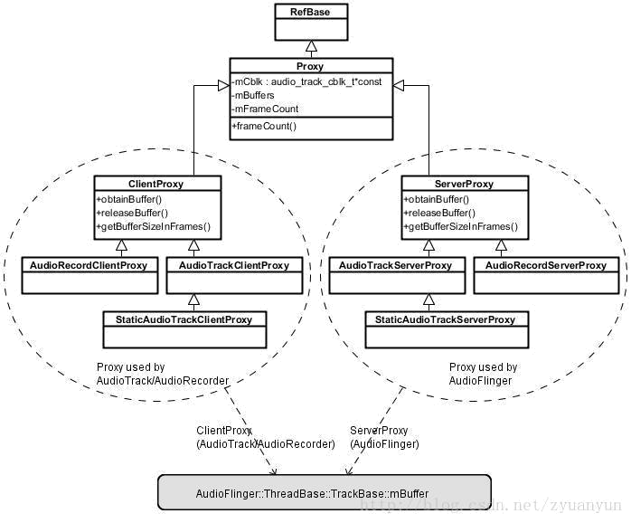

- audiotrackclientproxy: Mode_stream mode, producer Audiotrack uses it to find the location of free space in FIFO

- audiotrackserverproxy: Mode_stream mode, Consumer Audioflinger :: P laybackthread Use it to find the location of readable data in FIFO

- staticaudiotrackclientproxy: Mode_static mode, producer Audiotrack uses it to find the location of free space in FIFO

- staticaudiotrackserverproxy: Mode_static mode, Consumer Audioflinger

:: P laybackthread Use it to find the location of readable data in FIFO

- audiorecordclientproxy: Consumer Audiorecord uses it to find the location of readable data in FIFO

- audiotrackserverproxy: Producer Audioflinger :: recordthread uses it to find the location of free space in FIFO

